8.59:

After 0.500 s, 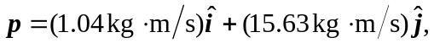and the velocity is

